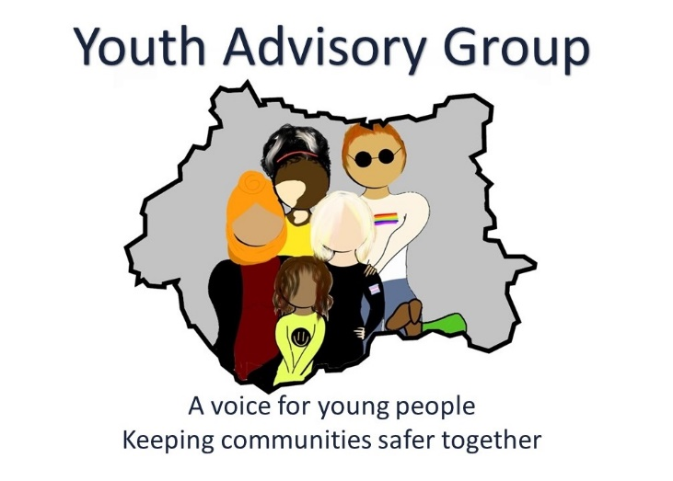

Photograph and video consent form

Dear parent/guardian,

We would be grateful if you could sign the attached form and return it to a member of staff. We cannot publish images or video of children/ young adults (age 17 and under) unless the form has been signed by a parent or guardian.

The photographs and video may be used in any of the media used by the Mayor of West Yorkshire, Deputy Mayor for Policing and Crime and the West Yorkshire Combined Authority for promotion including newsletters, leaflets, posters, the website and social media. They may also be circulated to the media.

Any photographs or video taken will be used only to promote the work of the Youth Advisory Group.

If at any time you wish your child’s photo or video to be no longer used, please contact us.

Thank you for your help.

External Affairs Team – Engagement
West Yorkshire Combined Authority

Tel 0113 348 1740
Email Consultation.PC@westyorks-ca.gov.uk

Youth Advisory Group

Consent for use of photos and videos

Name of child/young person:

The Mayor of West Yorkshire, Deputy Mayor for Policing and Crime and the West Yorkshire Combined Authority would like to take photographs and make a video recording of your child to promote the work of the Youth Advisory Group. These images may appear in our printed publications including newsletters, leaflets and posters and also our website and social media accounts. They may also be circulated to the media.

Please note that websites can be viewed throughout the world, not just in the United Kingdom where UK law applies. Please also note the conditions for using these images on the back of this form.

To comply with the Data Protection Act 1998, we need your permission before we take any photographs or recordings of your child. Please answer the following questions then sign and date the form where shown.

 | Please circulate your answer
May we use your child’s image in our printed promotional publications? | Yes / No
May we use your child’s image on our website and social media accounts? | Yes / No
May we record your child’s image on any of our promotional videos which may be circulated to the media? | Yes / No

I am the legal parent/guardian of the child/young person above and I give permission for my child to be photographed and recorded on video for media identified by the Mayor of West Yorkshire, Deputy Mayor for Policing and Crime and the West Yorkshire Combined Authority for the purposes of promoting the work of the Youth Advisory Group. I confirm that I have read and understood the conditions of use on the back of this form. I understand that there will be no payment for my child’s participation.

Signature of parent/guardian:

Name of parent/guardian (block capitals):

Address:

Date:

Conditions of use

This form is valid for four years from the date of signing and your consent will automatically expire after this time.

We will not re-use any images after this time.

If you would like to withdraw consent earlier than this, please contact the Engagement Team who will make sure the images are no longer re-used after consent has been withdrawn.

We will not include details or full names (which means first name and surname) of any child in an image on video, on our website or in printed publications.

We will not include personal e-mail or postal addresses or telephone or fax numbers on video or on our website or in printed publications.

Thank you for your co-operation

