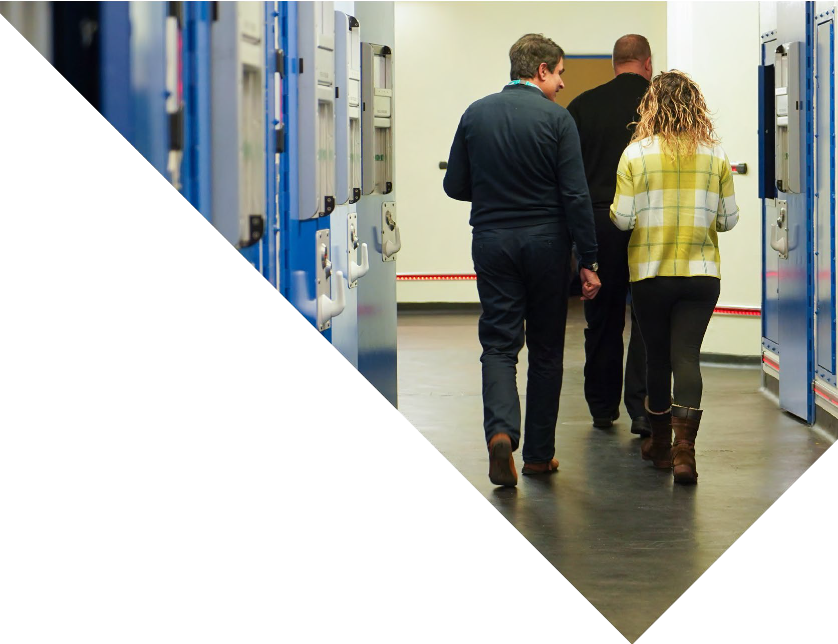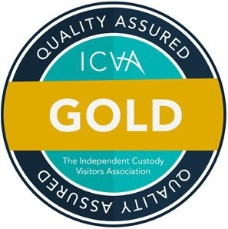

**West Yorkshire** Independent Custody Visiting Scheme

Providing transparency and reassurance

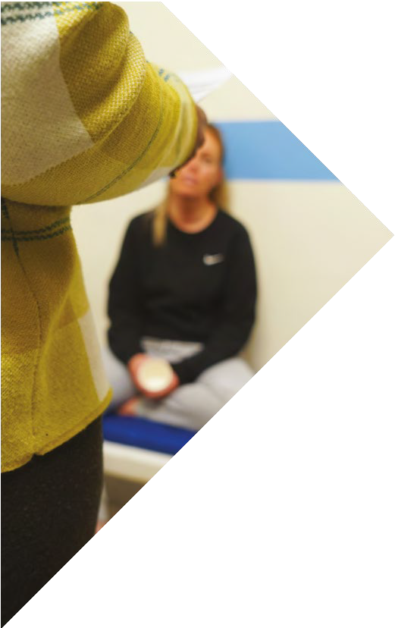

# About

Independent Custody Visitors (ICVs) are members of the local community who make unannounced visits to police station custody suites. They are volunteers and completely independent of the police service.

**ICVs are there to reassure the public that detention policies are being upheld, and people are being treated properly.**

**What** do ICVs do?

* On their visits, ICVs observe, comment and report on the conditions of the custody suites and check that the detainees are being properly look after.
* ICVs ensure that detainees understand their

rights and entitlements and check on their welfare.

* ICVs can also check around the cells, and some areas of the custody suite such as the food preparation area.

## **Where** do ICV visits take place?

* Our scheme covers the whole of West Yorkshire with custody suites in Bradford, Calerdale, Kirklees, Leeds and Wakefield.
* ICVs are eligible to claim reasonable travel expenses for undertaking visits and training.

## **How** many visits would I be required to do?

* ICVs visit in pairs, and can arrive at any time, 24 hours a day, 365 days a year without prior notice.
* ICVs make approximately 24 visits per year.

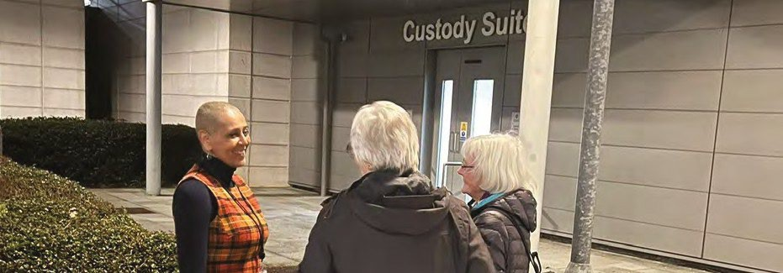

“It’s a job where I feel valued, and I feel that I add value to the detainees’ lives.”

West Yorkshire ICV

# Eligibility

ICVs are appointed for a 3-year period and:

* Live, work or study in West Yorkshire.
* Be over 18 years of age (at the time of appointment).
* Have been a UK resident for at least three years prior to date of application for vetting requirements.
* Be able to travel across West Yorkshire to custody suites.

# Training

ICVs are continually supported and provided with:

* A one-day training course (usually held on a Saturday) to equip you with the knowledge and skills to be effective in carrying out your role.
* A session on the administration arrangements of the scheme.
* A training visit to a custody suite.
* At least two custody visits in the company of experienced ICVs.
* Regular training sessions.



“I always feel I am supported. The office staff are great. There’s really good training to start with but we then have regular updates and if I’ve got any queries there’s always someone I can ask.”

West Yorkshire ICV

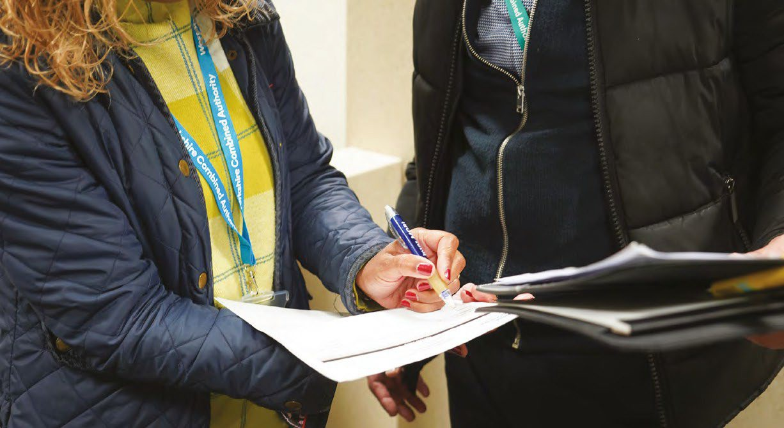

**@DeputyMayorPCWY**

# Get in Touch

ICVs are recruited by the Policing and Crime team at the West Yorkshire Combined Authority.

If you are interested in the role, would like more information or be notified of our next recruitment opening, please contact us:

**Email:** [policingandcrime@westyorks-ca.gov.uk](mailto:policingandcrime@westyorks-ca.gov.uk)

**Visit:** [www.westyorks-ca.gov.](https://www.westyorks-ca.gov.uk/icv)uk/icv

**Tel:** 0113 3481740

Please leave a voicemail and the team will call you back.

**Write:** Policing and Crime Team

West Yorkshire Combined Authority Wellington House

40-50 Wellington Street Leeds LS1 2DE

 **@DeputyMayorPCWY**